Dance. Inspired.

Ballet Palm Beach is a nonprofit 501(c)(3) organization dedicated to preserving the art of classical ballet, cultivating new visions in choreography, impacting the next generation through the discipline and power of dance, and enriching the community through this universal art form.
Founded by Artistic Director Colleen Smith in 2001, Ballet Palm Beach is THE professional ballet company of Palm Beach County and the Treasure Coast. It produces four main-stage productions in Palm Beach County each season and will expand its Florida reach to St. Johns County in the 2017/2018 Season.
The company strives to enrich the community and abroad through its numerous outreach programs and community performances. Currently, the company has four local outreach programs: Ballet by the Book, Flash Ballet, Discover Dance, and A Day at the Ballet. It also participates in international outreach through Ballet Ambassadors by working with global partners to bring ballet to underserved populations.
Its school, Ballet Palm Beach Academy, is celebrating 25 years this year, and it offers classes to students beginning at age 3 years old. The company offers traineeships to talented academy students who wish to experience a professional dance career. For more information about Ballet Palm Beach call (561) 630-8235 or visit www.balletpalmbeach.org.

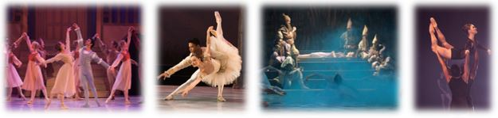

2017| 2018 SEASON

Snow White, Balanchine’s Who Cares? & Other Works
Saturday, October 14 at 7:30pm & Sunday, October 15 at 4pm
Eissey Campus Theatre at Palm Beach State College

The List & Other Works: Up Close with Ballet Palm Beach
Thursday, October 26 & Friday, October 27, 2017 • 7:30pm
Cocktails, Bites & Performances of: The List & Balanchine’s Who Cares?
Kravis Center for the Performing Arts • Rinker Playhouse

The Nutcracker
Friday, December 1 at 7:30pm, Saturday, December 2 at 2pm &
7:30pm, Sunday, December 3 at 2pm
Kravis Center for the Performing Arts • Dreyfoos Hall

Gatsby
Saturday, February 24 at 2pm & 7:30pm, Sunday, February 25 at 4pm
The Benjamin School • Benjamin Hall

A Midsummer Night’s Dream & Other Works
Saturday, May 5 at 7:30pm & Sunday, May 6 at 4pm
Eissey Campus Theatre at Palm Beach State College

Tickets for all shows start at just $19.

For tickets to all shows, visit
www.balletpalmbeach.org

For tickets to The Nutcracker:
Box Office: (561) 832-7469

For all other ballets:
Box Office: (561) 814-5598

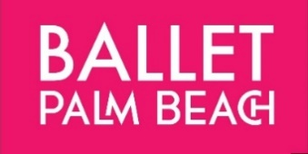
PLAYBILL ADVERTISING
Playbills are handed out at all season performances potentially reaching more than 15,000 patrons, including our brand-new Nutcracker at Kravis Center for the Performing Arts. Your business will be listed on the Ballet Palm Beach website under Corporate Sponsors.
Inside Cover $600 per show
☐The Nutcracker (Dec 1-3) ☐Gatsby (Feb 24-25) ☐ A Midsummer Night’s Dream (May5-6)
Inside back cover $500 per show
☐The Nutcracker (Dec 1-3) ☐Gatsby (Feb 24-25) ☐ A Midsummer Night’s Dream (May5-6)
Full Page (5.25 x 8.25) – $425 per show
☐The Nutcracker (Dec 1-3) ☐Gatsby (Feb 24-25) ☐ A Midsummer Night’s Dream (May5-6)
Half Page (5.25 x 4) – $250 per show
☐The Nutcracker (Dec 1-3) ☐Gatsby (Feb 24-25) ☐ A Midsummer Night’s Dream (May5-6)
Quarter Page (5.25 x 2)- $150 per show
☐The Nutcracker (Dec 1-3) ☐Gatsby (Feb 24-25) ☐ A Midsummer Night’s Dream (May5-6)
Advertising Deadlines: The Nutcracker (November 17) Gatsby (Feb 9) Midsummer Night’s Dream (April 20). Please send artwork as a pdf file to: marketing@balletpalmbeach.org.
Business/Individual Name:________________________________________________________

☐ Enclosed is my check made payable to Ballet Palm Beach for $_______________

☐ Please charge $_______________ to my: ☐Amex ☐Visa ☐Mastercard ☐Discover
Name (as on my card):___________________ Authorized Signature: _______________________
Card Number: __________________________Expiration Date:________Security Code:_______
Address: (local)____________________________________________
City: ____________________________________State: ________ Zip:______
Phone: (work/home/cell)_____________________E-mail:__________________________________
For more information please contact marketing@balletpalmbeach.org or 561-630-8235
Mail completed forms and checks to 10357 Ironwood Rd., Palm Beach Gardens, FL 33410

Ballet Palm Beach is a 501(c)(3) nonprofit organization. Tax Identification Number: 82-0569013

